**Presentation Notes:**

1. **What are the four functions of a computer program listed on the lesson slide?**

A Computer Program controls the hardware of a computer system.

Depending on the input devices affects the output devices.

* 1. How typing is displayed
  2. What happens when you click   
     a mouse button

1. **Provide an example of a computer input that is not listed on the lesson slide.**

* Power button
* Buttons on a monitor

1. **Provide an example of a computer output that is not listed on the lesson slide.**

* Speakers
* Headphones

1. **Provide another example of how a computer input affects a computer output that is not listed on the lesson slide.**

* Pressing the on button (input) the monitor (output) turns on.

1. **Provide an example of how changing the program changes how computer inputs affect computer outputs that is not listed on the lesson slide.**
2. **What are some examples of devices that are not traditional computers but that make use of computer programs?**
3. **Provide another example of a device that makes use of a computer program that is not listed on the lesson slide.**

* Toy cars
* GPS

1. **What is another term for a computer program?**

* Computer Software

1. **What are some ways that computer software is different from computer hardware?**

* Computer software uses logic (which is flexible and easily changed) and Computer hardware uses physical devise (hard to change).

1. **How are computer programs written?**

* Using different languages
* Logical statement of a command
* Each line does a very simple thing/ statement which adds out to doing a hard thing
* Computer programs are written using keyboard and text

1. **Why are computer programs composed of many lines of computer code?**

* Because each line is a simple command
* If you want something complicated, you use many simple lines of code to create a complex thing.

1. **List some examples of different computer languages.**
   1. python
   2. Java
   3. C/C+ for engineering
   4. COBOL / SQL for business
2. **List some of the benefits of the Python computer language.**
   1. Is a “professional” language with a large user base
   2. Is good for prototyping small programs
   3. It is a good beginner language
   4. It is the language of choice for 1st year university course
3. **Once you finish this course, how could you answer someone who asks you "Do you know how to program in Java?"**

* Yes, I know how to program and I could pick up Java in a short period of time.

1. **Could you use Microsoft Word to write a computer program? Explain.**

* You could, but it isn’t the most efficient.

1. **What does IDE stand for?**

* Integrated Development Environment

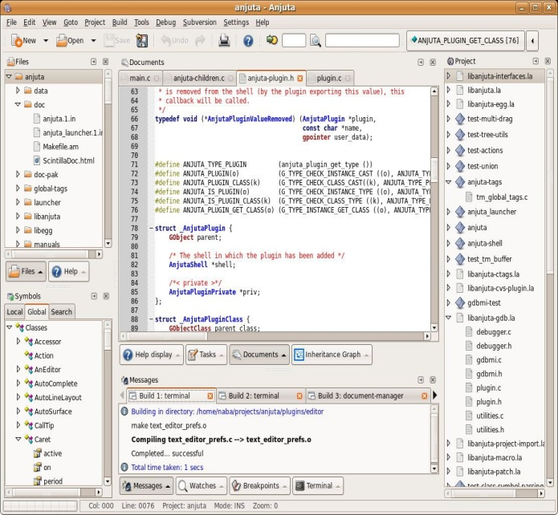

1. **What are some features of an Integrated Development Environment?**
   1. Colour coding of keywords
   2. Indentation and completion control
   3. Error Checking
   4. runtime Support and debugging.
2. **What are some factors to consider when choosing an Integrated Development Environment?**
   1. How well does it support your chosen language?
   2. Is it web based or a download install
   3. Other factors…
3. **What is the name of the IDE that we will be using to create our Python programs?**
   * Repl.it [www.repl.it](http://www.repl.it/)
4. **What version of Python will we be using?**

* Python 3.7.3 or 3.7.4 NOT Python 2.7

1. **Draw a sketch of the Repl interface showing the three work areas (panels)**
   1. **Label each panel**
   2. **Summarize the function of each panel**

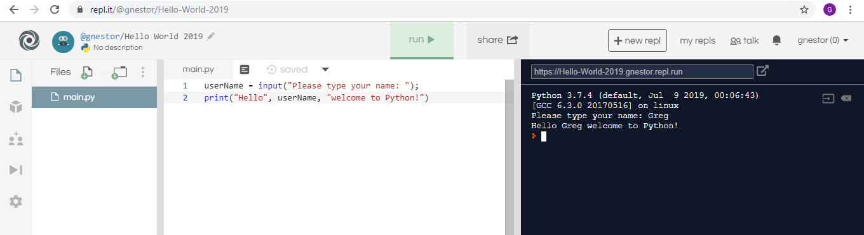

**Student Questions:**

1. **Create an account for yourself at www.repl.it**
   1. **Review the "Terms of Service" to verify that you can legally use this service.**
   2. **Follow the previous discussed guidelines regarding use of personal information**
2. **List the part of the "Terms of Service" that verifies that you can legally use this service.**
3. **Explain some of the rights that you give away to Repl.it regarding content you create using their service?**
4. **Create a new Python repl and call it "Hello World".**
5. **Copy and paste the following program into the program panel (white area)**

**userName = input("Please type your name: ");**

**print("Hello", userName, "welcome to Python!")**

1. **Run the program to see what it does. (If necessary, fix the quotation marks so it runs properly.)**
   1. **Explain how the program works.**
   2. **Explain how you fixed the program (if necessary)**
2. **Try using the console pane (black area) to perform some simple calculations and run some one-line programs.**
   1. **Summarize some of your calculations.**
3. **Try using the file management pane to add some files and folders to your repl.**
   1. **Summarize some of your additions.**